**Junior Infants - Academic year 2024/2025**

**Please purchase the following items that your child will need:**

**Stationery:**

5 Triangular Grip Pencils (labelled with name)

2 x A4 Mesh Zip Folder (See picture below)

1 Plastic Button Envelope A5 Size (see picture below)

Scissors (labelled with name)

2 Prittstick Glue (labelled with name)

Large Crayola Twistables – single colours, not rainbow.

Eraser and Sharpener (one that holds shavings)

1 Tub Playdough

1 Clear Mesh Pencilcase (See picture below)

*Please ensure that you* ***label*** *each pencil and twistable with your child’s name. This will save you* having to replace misplaced ones over the course of the year.

*Please also* ***label*** *the two folders and play dough with your child’s first name and* ***on a plain white label (89 x 36mm) preferably.***

Please note Scoil Mhuire NS operates a healthy eating policy to promote lifelong education on healthy eating for mind and body. Details of this policy can be found on our website www.schullns.com. We appreciate your co-operation in implementing this healthy eating policy in our school.

Our school has been awarded the Green Flag, we request that children use reusable and recyclable lunch and drink containers.

**Junior Infant Start and Finish Times – September 2024**

Wednesday August 28th 10am – 12:15pm

Thursday August 29th and Friday August 30th 9:20am – 12:15pm

Monday 2nd – Friday 13th September 9:20am – 1:15pm

Monday 16th September onwards 9:20am – 2:00pm

Please note: school gates are open @ 9:10am. Children are not to enter before this time. Children line up with their class and their teacher will collect the line and bring to the classroom at 9:20am. At home time, please wait outside the school wall and Ms. O’Donovan will bring the class outside to meet you.

We will hold informal parent teacher meetings with all class teachers in September. These proved to be very informative and worthwhile last year. At the meeting Ms. O’Donovan will share information re homework, reading, class trips etc., This meeting will be a good opportunity for you to build on the important and valuable relationship between home and school. Meetings will be held during the school day in September for approximately 20 minutes.

**Junior Infant Meeting will take place on Tuesday 17th September a 1:30pm**

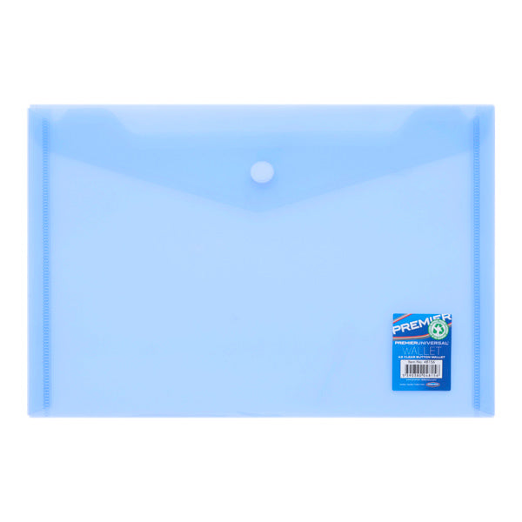

A5 Plastic Button Envelope Folder

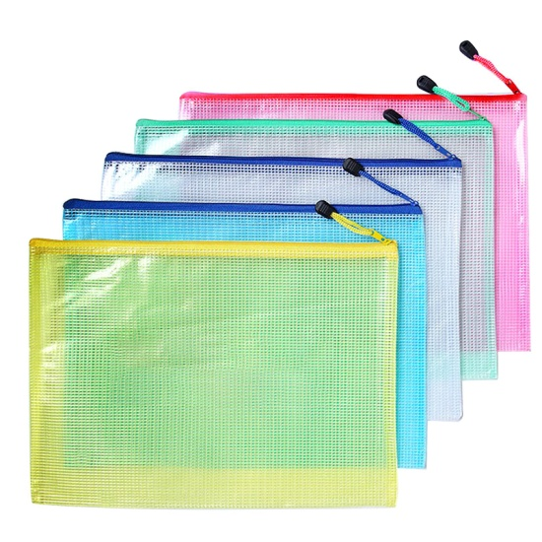

A4 Mesh Zip Folder

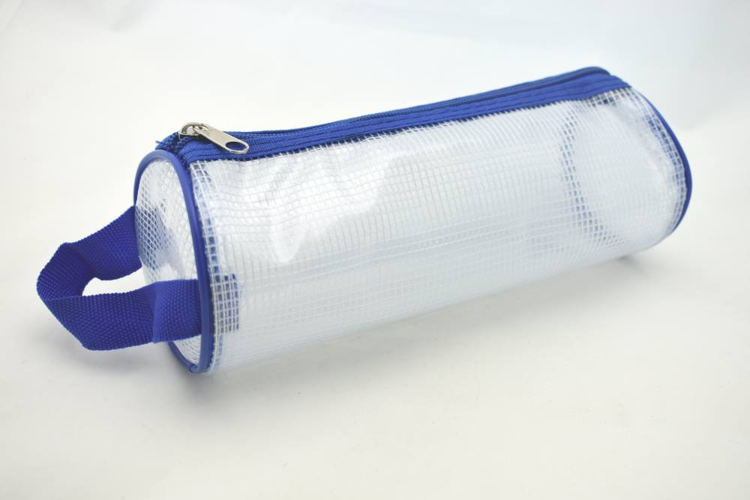

Clear Mesh Pencilcase Labelled with Name